Git Assignment

By Conor McDonald

Git Init

This command creates a . git subdirectory that goes in the directory you are working on.



git add

This command adds changes to the working directory and also the staging area.

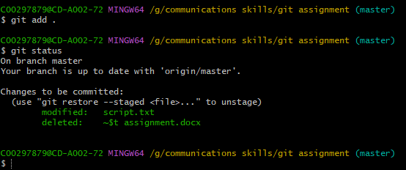

git status

This command shows the user the state of the working directory and the staging area at the current time used

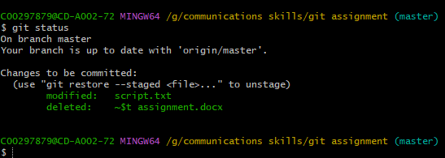

git commit

This command is used to take a note of the staged changes in your assignment's history



git remote

This command is used to make and delete connections to any repositories you have

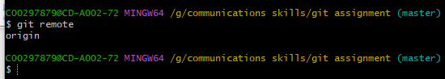

git push

This command is used to upload the items on the local repository to a remote repository.

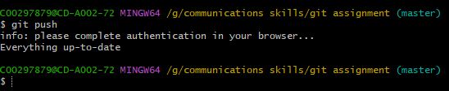

git branch

This command is used to highlight the changes the user has made to their git assignment



git clone

This command is used to create an identical copy of an already existing repository and use it in a different location

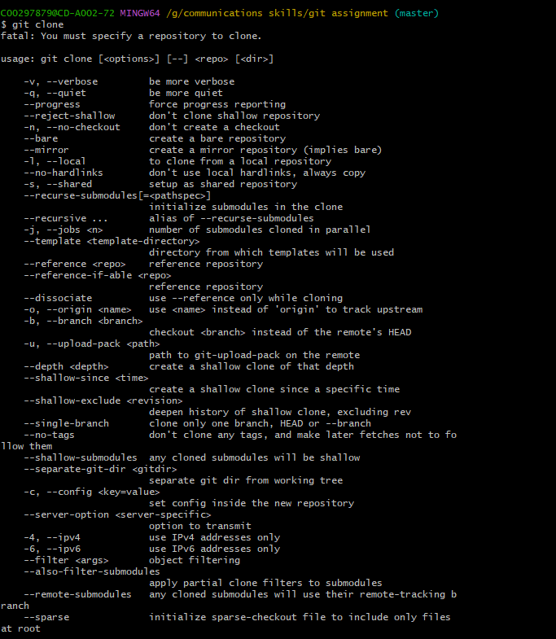

git log

This command is used to help a user search through the history of their assignment and find any specific changes they are looking for

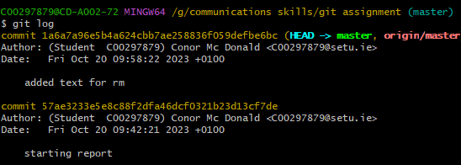

git rm

This command is used to remove files from the staging area, you can also format git to rm filenames

